Project Planning Phase
Project Planning Template (Product Backlog, Sprint Planning, Stories, Story points)

Date | 03 October 2026
Team ID | SWTID-2026-2035
Project Name | Implement Client Script & UI Policy (Incident)
Maximum Marks | 5 Marks

Product Backlog, Sprint Schedule, and Estimation (4 Marks)
Use the below template to create product backlog and sprint schedule
Sprint | Functional Requirement (Epic) | User Story Number | User Story / Task | Story Points | Priority | Team Members
Sprint-1 | Incident Configuration | US-01 | As a developer, I can configure the Incident form fields required by the project so that the form is ready for controlled field behavior. | 3 | High | Ahil R
Sprint-1 | Incident Configuration | US-02 | As a developer, I can define the UI Policy condition for the Incident form so that the required field behavior is triggered correctly. | 2 | High | Ahil R; Mohan Das K J
Sprint-1 | Incident Configuration | US-03 | As a developer, I can validate the Incident form behavior manually so that the configuration is ready for client-side scripting. | 1 | Medium | Mohan Das K J
Sprint-2 | Client Script | US-04 | As a developer, I can create the Incident Client Script with the required client-side logic so that the form responds to user actions. | 3 | High | Ahil R
Sprint-2 | Client Script | US-05 | As a developer, I can test the Client Script on Incident form load or change events so that the expected behavior is verified. | 2 | High | Ahil R; Shiva Prakash K R
Sprint-2 | Integration & Validation | US-06 | As a tester, I can verify that the UI Policy and Client Script work together without conflicting form behavior. | 2 | Medium | DILIBAN A; Venkatraghul M
Sprint-3 | Testing & Evidence | US-07 | As a tester, I can execute positive and negative Incident form test cases so that the configured behavior is evidenced. | 3 | High | Mohan Das K J; Shiva Prakash K R
Sprint-3 | Testing & Evidence | US-08 | As a team member, I can capture screenshots of the configured Incident behavior and relevant ServiceNow records for milestone evidence. | 1 | Medium | DILIBAN A; Venkatraghul M
Sprint-4 | Documentation | US-09 | As a team member, I can organize project evidence and implementation details so that the final submission is traceable to the milestones. | 2 | High | DILIBAN A; Venkatraghul M
Sprint-4 | Documentation | US-10 | As a team, we can review the final Incident Client Script and UI Policy implementation and confirm that the documented result matches the demonstrated behavior. | 1 | High | Ahil R; Mohan Das K J; DILIBAN A; Shiva Prakash K R; Venkatraghul M

Project Tracker, Velocity & Burndown Chart: (4 Marks)
Sprint | Total Story Points | Duration | Sprint Start Date | Sprint End Date (Planned) | Story Points Completed (as on Planned End Date) | Sprint Release Date (Actual)
Sprint-1 | 6 | 1 Day | 28 Sep 2026 | 28 Sep 2026 | 6 | 28 Sep 2026
Sprint-2 | 7 | 1 Day | 29 Sep 2026 | 29 Sep 2026 | 7 | 29 Sep 2026
Sprint-3 | 4 | 1 Day | 30 Sep 2026 | 30 Sep 2026 | 4 | 30 Sep 2026
Sprint-4 | 3 | 1 Day | 01 Oct 2026 | 01 Oct 2026 | 3 | 01 Oct 2026

Velocity:
For this 4-day project plan, 20 total story points are planned across four one-day sprints. Using the planned workload, the average planned velocity is 20 / 4 = 5 story points per day.

Burndown Chart:
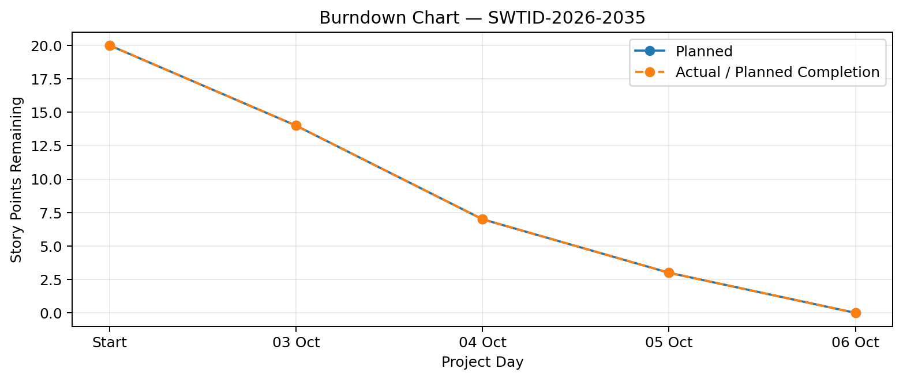
A burn down chart is a graphical representation of work left to do versus time. It is often used in agile software development methodologies such as Scrum. However, burn down charts can be applied to any project containing measurable progress over time.

https://www.visual-paradigm.com/scrum/scrum-burndown-chart/
https://www.atlassian.com/agile/tutorials/burndown-charts

Reference:
https://www.atlassian.com/agile/project-management
https://www.atlassian.com/agile/tutorials/how-to-do-scrum-with-jira-software
https://www.atlassian.com/agile/tutorials/epics
https://www.atlassian.com/agile/tutorials/sprints
https://www.atlassian.com/agile/project-management/estimation
https://www.atlassian.com/agile/tutorials/burndown-charts

